Switch to a database.  
**mysql> use [db name];**

To see table's field formats.  
**mysql> describe [table name];**

To delete a db.  
**mysql> drop database [database name];**

To delete a table.  
**mysql> drop table [table name];**

Show all data from a table.  
**mysql> SELECT * FROM [table name];**

To return columns and column information.  
**mysql> show columns from [table name];**

Show particular rows with the given value.  
**mysql> SELECT * FROM [table name] WHERE [field name] = "value";**

Show all records containing the name "Something" AND the phone number '0123456789'.  
**mysql> SELECT * FROM [table name] WHERE name = "Something" AND phone_number = '0123456789';**

Show all records not containing the name "Something" AND the phone number '0123456789' order by the phone_number field.  
**mysql> SELECT * FROM [table name] WHERE name != "Something" AND phone_number = '0123456789' order by phone_number;**

Show all records starting with the letters '**Something**' AND the phone number '0123456789'.  
**mysql> SELECT * FROM [table name] WHERE name like "Something%" AND phone_number = '0123456789';**

Show all records starting with letters 'Something' AND the phone number '0123456789' limit to records 1 through 5.  
**mysql> SELECT * FROM [table name] WHERE name like "Something%" AND phone_number = '0123456789' limit 1,5;**

Show selected records sorted in an ascending (asc) or descending (desc).  
**mysql> SELECT [col1],[col2] FROM [table name] ORDER BY [col2] DESC;**

Return number of rows.  
**mysql> SELECT COUNT(*) FROM [table name];**

Show unique records.  
**mysql> SELECT DISTINCT [column name] FROM [table name];**

Sum column.  
**mysql> SELECT SUM(*) FROM [table name];**

Delete a row(s) from a table.  
**mysql> DELETE from [table name] where [field name] = 'fieldvalue';**

Delete a column.  
**mysql> alter table [table name] drop column [column name];**

**ALTER table laundrytec.estadisticas drop column testing;**

Add a new column to db.  
**mysql> alter table [table name] add column [new column name] varchar (20);**

**ALTER table laundrytec.estadisticas add column testing varchar(20);**

Make a column bigger.  
**mysql> alter table [table name] modify [column name] VARCHAR(3);**

Load a CSV file into a table.  
**mysql> LOAD DATA INFILE '/tmp/filename.csv' replace INTO TABLE [table name] FIELDS TERMINATED BY ',' LINES TERMINATED BY '\n' (field1,field2,field3);**

**UPDATE:**

UPDATE employee 7  
SET location ='Mysore'   
WHERE id = 101;

Select Range

SELECT * FROM [table] WHERE [column] BETWEEN [value1] and [value2];

Delete all records in a table: truncate table [table];

* We cannot use Where clause with TRUNCATE.
* TRUNCATE removes all rows from a table.
* The operation cannot be rolled back.

Deleting tables: DROP TABLE [table];

* The DROP command removes a table from the database.
* The operation cannot be rolled back.
* DROP and TRUNCATE are DDL commands, whereas DELETE is a DML command.

Deleting tables: DELETE FROM employee WHERE id = 100;

* We can use where clause with DELETE to filter & delete specific records.
* It maintain the log, so it slower than TRUNCATE.
* The operation can be rolled back

:JOINS:

**INNER JOIN**

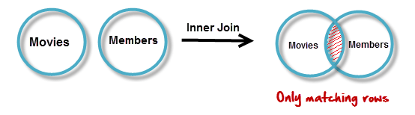

SELECT members.`first_name` , members.`last_name` , movies.`title`

FROM members ,movies

WHERE movies.`id` = members.`movie_id`

Othereway

SELECT table1.column1,table1.column2,table2.column1,....

FROM table1

INNER JOIN table2

ON table1.matching_column = table2.matching_column;

Syntax:

SELECT *

FROM table1

INNER JOIN Table2

On table1.matchingcolumn =table2.matching.column

**OUTER JOIN 🡪 LEFT OUTER JOIN and RIGHT OUTER JOIN**

**LEFT OUTER JOIN**

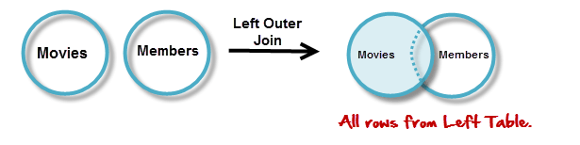

SELECT A.`title` , B.`first_name` , B.`last_name`

FROM `movies` AS A

LEFT JOIN `members` AS B

ON B.`movie_id` = A.`id`

**Otherway:**

SELECT table1.column1,table1.column2,table2.column1,....

FROM table1

LEFT JOIN table2

ON table1.matching_column = table2.matching_column;

**Syntax:**

Select *

From table1

LEFT JOIN Table2

Where table1.matchingcolumn= table2.matchincolumn

**RIGHT OUTER JOIN**

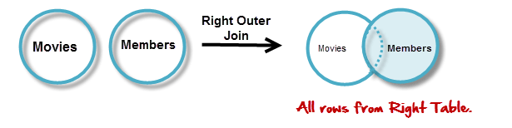

SELECT A.`first_name` , A.`last_name`, B.`title`

FROM `members` AS A

RIGHT JOIN `movies` AS B

ON B.`id` = A.`movie_id`

**Other way:**

SELECT Student.NAME,StudentCourse.COURSE_ID

FROM Student

RIGHT JOIN StudentCourse

ON StudentCourse.ROLL_NO = Student.ROLL_NO;

**Syntax:**

Select *

From table1

RIGHT JOIN table2

Where table1.matchingcolumn=table2.matchingcolumn

**Full JOIN**

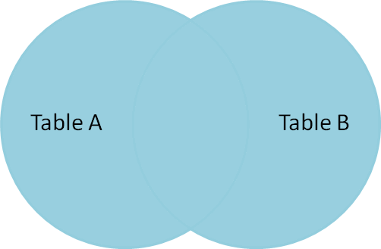

**Example Queries(FULL JOIN)**:

SELECT Student.NAME,StudentCourse.COURSE_ID

FROM Student

FULL JOIN StudentCourse

ON StudentCourse.ROLL_NO = Student.ROLL_NO;

**Syntax:**

Select *

From table1

FULL JOIN table2

Where table1.matchingcolumn=table2.matchingcolumn

**What is subquery:**

Select fname, lname

FROM employee

Where UID IN (Select UID

FROM Office

Where Country=’India’ )

**Write Sql Query to get the third hight salary from the employee table:**

Select Top 1

From (Select Top 3

From Employee

Order by Salary Desc) Order by salary ASC.

**Return employee record with highest salary**

Select *

From Employee

Where salary =(Select Max(salary) from Employee)

**Onother query**

SELECT * FROM employee ORDER BY salary DESC LIMIT 1

**Select highest salary from employee table:**

Select Max(salary) from Employee

**Return employee record with second highest salary**

Select Max(salary)

from Employee

Where Salary Not in (Select Max(Salary)

From Employee)

**How can you fetch first 5 characters of a String?**

Select SUBSTRING(studentname,1,5) as studentname

FROM Student